TI 22 – 46. Technology Example – Well-Sense FLI system

FLI Probe

The Well-Sense FLI probe is a single-use device, containing the spooled fibre-optic line and optional electronic sensors.
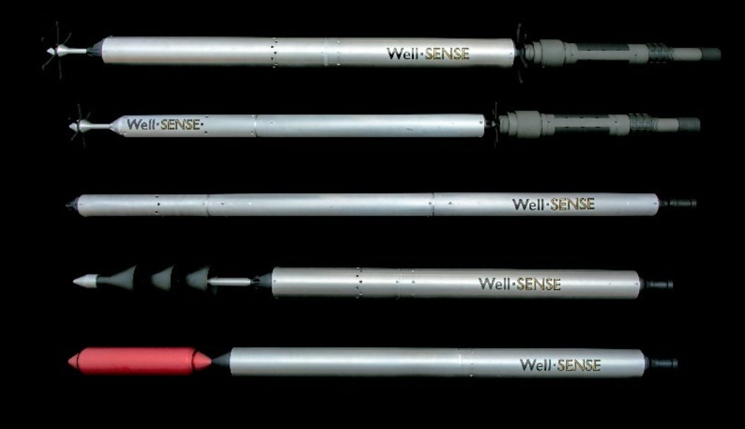

FLI probes are designed to be light, compact and robust, enabling easy handling at the wellsite and reliable deployment in the well.
They are light, typically weighing less than 5 kg, and compact, typically being less than 1.5m in length, and can easily be handled by one person. As standard, the probes are made using aluminium alloy and incorporate a number of features designed to protect the optical fibre as it unspools during free-fall into the well.

The FLI probe contains one or more spools of bare optical fibre up to 25,000ft (7,715 m) long.
The probe is a simple device, but with some special features. It houses one or more custom designed bobbins, on each of which we wind a bare optical fibre – i.e., the glass is protected by nothing other than its polymer coating. Our bobbin winding technique is proprietary, designed to ensure that long optical fibres can be unspooled reliably at high speeds.
The length of fibre that can be unspooled from a FLI probe depends upon its size, but typically ranges from 3800m to 7,715m, but this is not a hard upper limit. Greater fibre lengths are easily achievable, if required, with larger probes.

We can supply Active-FLI probes, fitted with electronic sensors and optical telemetry.
FLI is primarily designed to be a distributed sensing system, in both space and time – observing the wellbore simultaneously along the entire length of the unspooled fibre. Nevertheless, it is sometimes useful to enhance the distributed sensing with single point sensors, and even sources, embedded in the FLI probe itself. We refer to these as Active-FLI.
As just one example, we can supply FLI probes fitted with short-term pressure/temperature gauges, interrogated using our proprietary optical telemetry system.

